Matthew Hancock & Rachel Burk

CSC481 – Dr. Nelson

Literature Review

We reviewed pedagogical topics specifically from University of Colorado’s Center for Faculty Development. The process for designing this course will require three stages.

The first stage of the course design will be to outline each chapter that we will cover in the DataCamp Light course. The Python for Everybody book already has chapters broken into no more than 16 subsections. The benefit of this structure is that it helps to structure our course as well as influence learning objectives. The first stage’s primary focus is to write “observable learning objectives” which according to the University of Colorado’s Center for Faculty Development states they “provide students with a clear purpose to focus their learning efforts.” A great distinction provided in this material is the importance of learning goals and learning objectives. The difference between them is “learning Goals are what you hope to accomplish in your course: the overall goals that do not necessarily result in products of observable and measurable behavior”. While “learning objectives are brief, clear statements about what students will be able to do when they complete instruction”. This is significant for course design because of how concise learning objectives must be in order to check that students will complete the material successfully.

As mentioned earlier, learning objectives need to be observable and measurable. Learning objectives include the following:

* Condition - the condition under which the student will perform the described behavior
* Behavior - a description of a specific, observable behavior
* Degree - the degree indicates the desired level or degree of acceptable performance

This course for example, a learning objective for the first chapter would be the

* condition: “identify the reserved words in python”
* behavior: students will be able to pick the reserved python words from a list
* degree: students will be able to identify reserved words 80% of the time.

Below is a table of observable behaviors that we will be using in order to construct our learning objectives. Ideally, each module will have multiple learning objectives per chapter and will be tested with a variety of process “levels.”

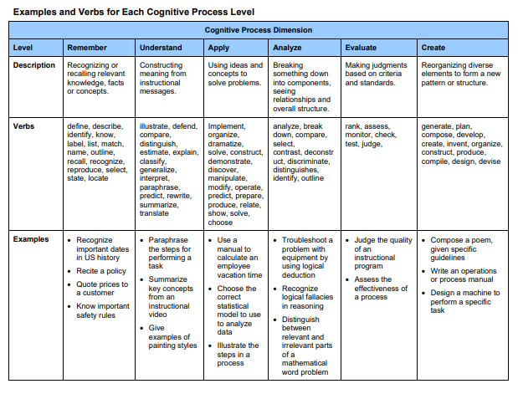

The second stage of the course design will be to create interactive activities and assessments to guide learning. Activities will depend greatly on the process level decided for the learning objective. DataCamp light offers the ability to utilize multiple choice and console practices as both activities and assessments. DataCamp light uses remembering, understanding, applying, and creating levels. This benefits the student because they will be assessed the same way they are practicing. This will also be the case throughout their learning journey with Saint Martin’s University. Through my experience, professors use similar tools to create activities and assessments. As visualized below, utilizing many process levels to achieve a learning objective may be most effective. Multiple-choice questions are great for an activity that requires remembering and memorizing. Reserved words, for example, would greatly benefit from multiple-choice. The console activities allow students to apply and create code in order to understand more hands-on topics such as loops.

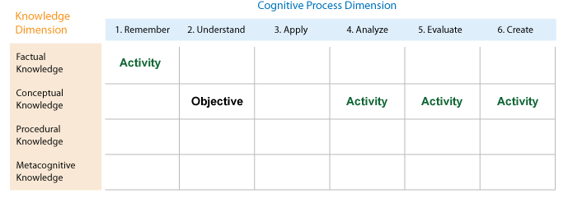

The third stage is implementation and documentation. The implementation will take place through GitHub and DataCamp Light. This will require us to understand the commands that DataCamp Light recognizes and structure our activities in that way. Doing this process with GitHub allows us to document and implement the material. This is especially important because there is a great likelihood that Python for Everybody through DataCamp Light will need to be worked on by a second senior team. The way that we will handle this transition is to comment our content well, and to leave detailed instructions on the direction we were looking to head for the content.

The goal for this project is to complete the first 6 chapters at least. This gives us the opportunity to work with Dr. Nelson on the content as well as fish out any bugs that might arise with the code. Future reviews of literature describing the best methods to create multiple-choice and console content will be required as we continue to develop the course.